X - Personnel balance: inclusiveness, well-being and diversity inside INFN through a gender perspective

X.1.1 Structure and staff, a gender and generational perspective.

A more extended analysis focused on gender and generational differences within INFN has been presented by CUG in its annual report on equality, equal opportunity, well-being and discrimination:
https://web.infn.it/CUG/images/alfresco/Cug/2016/20160330-RelazioneCUG2015.pdf
The analysis has been submitted to the Executive Board who recognized that there is a statistical evidence supporting the existence of discriminations although they are not able to recognize the cause:
https://docs.infn.it/share/page/site/cug/document-details?nodeRef=workspace://SpacesStore/d142e926-0e38-4463-a2f0-dd3b12b773ac

The INFN employees are divided in four categories: researchers, technologists, technicians and administrative personnel. From the INFN annual report to the Treasury, updated to 31 December 2014, the persons with a permanent position are 1725; women are about 24.7% of them. In the permanent positions of researcher and technologist, women are always less than 20%. Additionally there are 225 people with a non permanent contract, between them the women are 28% of the researchers and 21% of the technologists. Let us remind that the degrees in physics awarded to women in Italy are between 32% to 38% each year at least since 1999.
Table 1 reports the number of men and women staff for each category and professional level (from the highest I to the lowest VIII); for each category and sex the fraction of employees in a given level is also reported in parentheses.
Vertical segregation. From Table I it is evident that the probability for a man to achieve the highest professional level is larger than for a woman. For the researchers 1/5 of the men is at the first wage level while less than 1/10 of the women is in the same level. A larger discrepancy is observed for the technologist: just 2 women (6% of the women employed as technologist) are in the first level compared to 18% of men. This discrepancy cannot be attributed to a different age distribution or a different age in hiring, as these distributions are the same for women and men. The discrepancy has not decreased after the last public selections exploited in 2015 for the promotion to the first wage level where only a woman has achieved the first level as researcher against 13 men (7 researchers and 6 technologists). It is interesting to compare this data with the 2012 national scientific qualification (“abilitazione nazionale”), where the INFN female researchers obtained the qualification with probabilities larger or equal to their male colleagues.
The different distribution in the levels between administrative staff and technician is due to a difference foreseen by the national contract: an academic degree is required to achieve the IV wage level for the administrative staff but not for technicians. This “difference” can be seen an example of indirect discrimination and has been notified to the trade union representatives.

Table 1: Distribution of the INFN personnel with a permanent contract for each category and professional level, updated to the 31 December 2014. People at manager level (there is just a woman in second manager level) are not inserted in the table. For each category and sex, the fraction of employees in a given professional level is also reported in parentheses.
For any given category, the percentage of men and women is reported in parentheses in the second to last line, meanwhile the number of employees and their percentage respect to the total (in parentheses) are shown in the last line.

Category /  Level | Researchers |  | Technologists |  | Category /  Level | Administrative staff |  | Technicians
 | Men | Women | Men | Women |  | Men | Women | Men | Women
I | 90 (20%) | 11 (9%) | 33 (18%) | 2 (6%) | IV | 10 (20%) | 37 (16%) | 294 (48%) | 16 (47%)
II | 196 (43%) | 64 (50%) | 74 (40%) | 12 (38%) | V | 27 (53%) | 137 (59%) | 163 (27%) | 8 (24%)
III | 168 (37%) | 52 (41%) | 78 (42%) | 18 (56%) | VI | 13 (25%) | 44 (19%) | 131 (21%) | 10 (29%)
 |  |  |  |  | VII | 1 (2%) | 14 (6%) | 11 (2%) | 0
 |  |  |  |  | VIII |  |  | 10 (2%) | 0
Total for gender | 454 (78%) | 127 (22%) | 185 (85%) | 32(15%) |  | 51 (18%) | 232(82%) | 609 (95%) | 34 (5%)
Total for category | 581 (34%) |  | 217 (13%) |  |  | 283 (16%) |  | 643 (37%)

Generational segregation: The age distributions of the INFN employees for the four categories are shown separately for sex in Fig. 1. All the distributions are peaked at the age of about 50 years. The employees younger than 40 years represent a very small fractions: 6% of the researchers, 4% of the technologists, 8% of the technicians and 8% of the administrative staff, in 2003 they were 20% of the researchers, 31% of the technologists, 35% of the technicians and 39% of the administrative staff. These data highlight that people younger than 40 years had small or no possibility to be hired for a job in a research institute. When hired, at 35-40 years of age, it is unlikely that they will have a good professional career because of the small number of positions open for promotions. Furthermore, the low number of young technicians in the INFN structure local laboratories, corresponds to a loss in transferring technical competences between different generations.

Researchers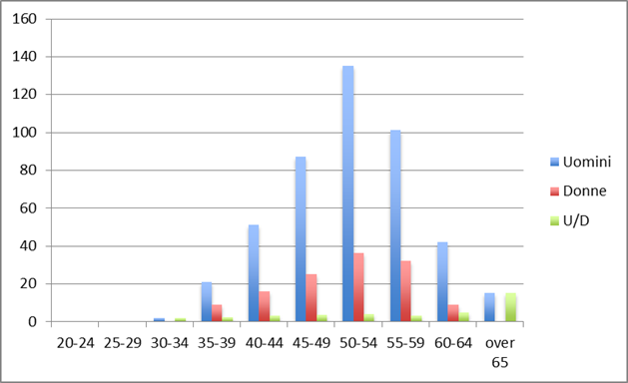 | Technologists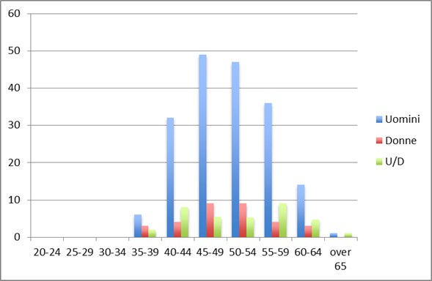
Technicians  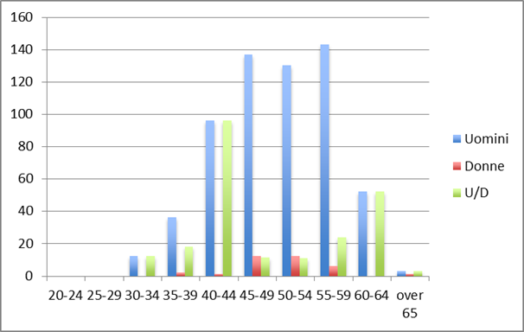 | Administrativestaff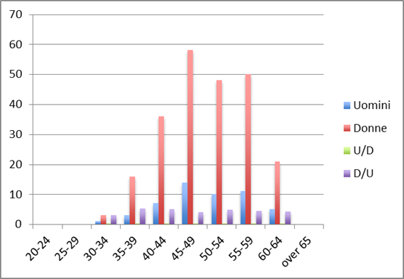
Figure 1. Age distributions of the INFN employees for men (blue symbols) and women (red symbols) for the four categories. The green symbols represent the men/women ratio for each age bin. For the administrative staff, the women/men ratio for each age bin is reported with a violet symbol.

Horizontal segregation between scientific committees. In Table II the fraction of women/total for the five National Scientific Committees (CSN) is shown; data are taken from the 2014 scientific database. The presence of women is not uniform across the different CSNs: women are well represented in CNS2, CNS3 and CNS5 (astrophysics, nuclear physics and technological applications, respectively) but not in CNS4 (theoretical physics) that appears to be able to attract or retain mainly male researchers.
Scientific production. The scientific production of the women, estimated by the number of PhD thesis and number of talks, is relevant. The number of women covering scientific responsibilities, as convener or local or national group responsible is larger or at least equal to their FTE (Full Time Equivalent) fraction in the different committees (except CSN5). From this table it is evident that the women are fully contributing to the scientific life of the INFN also fully covering scientific responsibilities.

Table II: Fraction of women/total in the five National Scientific Commissions. Data from the 2014 scientific database.
2014 | CSN1 (%) | CSN2 (%) | CSN3 (%) | CSN4 (%) | CSN5 (%)
Conveners | 21 | 31 | 23 | 16 | 13
National resp. | 20 | 23 | 41 | 13 | 14
Local resp. | 24 | 16 | 25 | 16 | 18
FTE (INFN + Univ.) | 19 | 22 | 28 | 14 | 27
Talks | 26 | 33 | 31 | 16 | 33
PhD Thesis | 26 | 38 | 36 | 16 | 22

Gender balance in management and consultative bodies. In spite of the fact that female researchers are well represented in scientific committees resulting from an election, i.e. in the CSN they are 20%, women are under represented in scientific or technical bodies appointed by management boards, as can be seen in Table III. The most critical examples are (at this date): the Scientific Committee of LNL and LNF (7 men and no woman), the Scientific Committee of SPES Project (12 men and no woman) and the National Committee for the Technological Transfer (7 men and no woman), despite the fact that there are 6 women (22%) as local contact persons for the technological transfer.
Table III: Fraction of women/total in scientific and technical committees appointed by the INFN President and/or by the management boards and elected scientific commissions. Data updated to April 2016.
APPOINTED SCIENTIFIC BODIES | # of men | # of women | Fraction of women/total
Consiglio Tecnico Scientifico | 4 | 1 | 0.20
Com. Scientifico LNF | 7 | 0 | 0
Com. Scientifico LNGS | 7 | 2 | 0.22
Com. Scientifico LNL | 7 | 0 | 0
Com. Scientifico LNS | 5 | 2 | 0.29
Com. Tecnico Scientifico CNAF | 6 | 1 | 0.14
Com. Tecnico Scientifico GSSI | 5 | 1 | 0.17
Com. Scientifico Progetto SPES | 12 | 0 | 0
Comm. calcolo Reti | 34 | 6 | 0.15
Comm. Naz. Trasf. Tecnologico | 7 | 0 | 0
ELECTED SCIENTIFIC BODIES
CSN 1-5 | 92 | 23 | 0.20

X.1.2 Work done and to be done in connection to INFN Plan of Positive Actions (PTAP)
Increasing transparency in decision-making processes and the flow of information

A lot of work has been done on the Transparency: INFN now has a good Transparency public page with lots of information on the organization, available to everybody. But lack of transparency continues to affect structures and processes, with the associated phenomenon of “old boys” networks and patronage. Evidence suggest that women and men would both benefit from a system where there is clarity of what is required from employees, information is freely available, and clear criteria are used in decision making.
In connection with this point and to PTAP
specific objective 3.2, CUG made a comparison of actual levels of gender composition in the workforce including various levels of management and leadership (see the previous Tables II and III), a more balanced participation of women in decision-making bodies is required;
specific objective 2.2, CUG asked for an “open consultancy procedure” to acquire personnel availability in case of vacant positions of responsibility, institutional commissions, etc. Such a procedure has been adopted by INFN, for the first time, on March 2015 for the CUG component selection.
Both points can be linked to a more appropriate training on diversity, on leadership, on gender issues

Removing unconscious bias from institutional procedures.

Recruitment procedures – Between the end of 2015 and the Summer 2016, the EU “Minerva” code for recruitment procedure of researchers was finally entirely adopted by INFN inside the new Regulation of Competitions with the aim of improving fairness and transparency in selection procedures. Scientific curriculum of the candidates will be published within an internal INFN web page and all the evaluation criteria will be published with the job description.

Enhancement of human resource in the working environment

Circles of organizational listening. -- As mentioned in the last year report, on the basis of the results of the analysis performed on the “Organizational wellbeing” by the Ombudsperson -“Consigliera di Fiducia”- in collaboration with CUG – an experimental program on “Circles of organizational listening” has been approved. The project started, from September 2015 to January 2016, in four sample INFN sites of different size and characteristics, in order to understand the feasibility and the integration in the INFN specific working organization (CNAF,LNGS, NA,TO). The aim was to build up a path to involve staff in a process, from the bottom, of deepening problems/organizational procedures/gaps in the different structures and finding possible, real solutions on the base of common ground of shared values and objectives. The work was done in agreement with the local management.
Some real solution have been found, even if not yet implemented, people learned to know and to work better with the others, to listen diversity, to analyse problems and find concrete solutions, even small in order to promote wellbeing in the workplace. The work will be continued by the new Ombudsperson adopting better the model to the INFN environment.

X.2 European Gender Project: GENERA
The project “GENERA – Gender Equality Network in the European Research Area” - born inside the European network APPEC (Astroparticle Physics European Consortium), has been approved inside the Horizon 2020 program Science with and in Society, GERI.4.2014. It will cover a three year period (2015 – 2018).
The project aims to develop a common framework to promote gender equality in European research organizations operating in the field of physics. In particular, physics has been chosen as the first field where implementing customized Gender Equality Plans (GEP).
According to the EU, physics is one of the scientific discipline with the lowest women representation at all career levels and it still has a highly unbalanced gender representation. This requires a coordinated European approach to make physics research more inclusive for women and by that make the field contribute even better to the challenges of responsible research and innovation in the European Research Area.
“Fixing the data" is the first important point in order to determine the status quo of gender equality promotion in the partner Institutions (research performing organizations (RPOs), research funding organizations (RFOs) and Universities). This means to collect, for each partner, important data on staff researcher, that is to say demographic data (sex, age,…), qualification and specific activity sector, career path, working organization (parental leave, part – time, teleworking, …) . The analysis of this data will allow to photograph the profile of the women distribution for each institution at the beginning of the project. The collection work is started also inside INFN, between 2015 and 2016.
The second work package of the project concerns the identification of existing gaps in current gender activities (in particular in the existing Gender Equality Plans), to determine specific needs or actions to improve gender equality in physics, identifying and analyzing the best practices and the strategies to overcome barriers and obstacles, thus implementing gender equality measures in research in Physics.
To realize these objectives, Gender in Physics Days is one of the operating tools that will be used. They are information days, to be once organized by each partner organization. Their aim is to:
- Sensitize on the importance of gender equality;
- Present and discuss the past and present activities and policies.
In 2017 INFN will organize a Gender in Physics days in collaboration with CNR partners.

